Program Overview
TIME | Tuesday 12th  November | TIME | Wednesday 13th  November | TIME | Thursday 14th  November | TIME | Friday 15th  November
08:00 – 09:00 | Registration | 08:00 – 09:00 | Registration | 08:00 – 08:30 | Registration | 07:00 – 13:00 | Guided Tour  Visit to  1) Songpa Safety Experience Education Center  2) Lotte Tower (Safety Control Center)
09:00 – 09:10 | Welcome & Introduction of the Workshops  (Room 302) | 09:00 – 10:30 | Plenary Session 1(3)  Keynote Speakers  (Room 303) | 08:30 – 11:00 | Plenary Session 2(5)  Keynote Speakers  (Room 303) | 07:00 – 13:00
09:10 – 11:00 | Workshop 1  (Room 302) | 10:30 – 10:45 | Welcome & Opening  (Room 303)
11:00 – 11:20 | Coffee Break with visit to Posters & Exhibition | 10:45 – 11:00 | Coffee Break with visit to Posters & Exhibition | 11:00 – 11:20 | Coffee Break with visit to Posters & Exhibition | 07:00 – 13:00
11:20 – 13:00 | Workshop 2  (Room 302) | 11:00 – 12:00 | Plenary Session 1(2)  Keynote Speakers  (Room 303) | 11:20 – 13:00 | Technical Session 5(5) (Room 301)  Technical Session 6(5) (Room 302)  Korean Session 3(4) (Room 307A) | 07:00 – 13:00
11:20 – 13:00 | Workshop 2  (Room 302) | 12:00 – 13:00 | TIEMS  Annual General Meeting  (Room 303)
13:00 – 14:00 | Lunch with visit to Posters & Exhibition | 13:00 – 14:00 | Lunch with visit to Posters & Exhibition | 13:00 – 14:00 | Lunch with visit to Posters & Exhibition | 13:00 – 14:00 | Late Lunch
14:00 – 15:40 | Workshop 3  (Room 302) | 14:00 – 15:40 | Technical Session 1(4) (Room 301)  Technical Session 2(4) (Room 302)  Korean Session 1(4) (Room 307A) | 14:00  – 16:00 | Technical Session 7(5) (Room 302)  Korean Session 4(5) (Room 307A)  Korean Session 5(6) (Room 301) | 14:00 | Farewell
15:40 – 16:00 | Coffee Break with visit to Posters & Exhibition | 15:40 – 16:00 | Coffee Break with visit to Posters & Exhibition | 16:00 – 16:20 | Coffee Break with visit to Posters & Exhibition | 14:00 | Farewell
16:00 – 18:00 | Workshop 4  (Room 302) | 16:00 – 18:00 | Technical Session 3(5) (Room 301)  Technical Session 4(6) (Room 302)  Korean Session 2(7) (Room 307A) | 16:20  -16:40 | Announcement for TIEMS 2020  (Room 302) | 14:00 | Farewell
18:00 – 20:00 | Welcome Reception  (Room 303) | 18:00 – 20:00 | Gala Dinner  (Room 303) | 16:40  -17:00 | Summary & Conclusions  (Room 302) | 14:00 | Farewell
20:00 | Finish Day 1 | 20:00 | Finish Day 2 | 17:00 | Finish Day 3 | 14:00 | End of Conference

Guidence for Conference Rooms
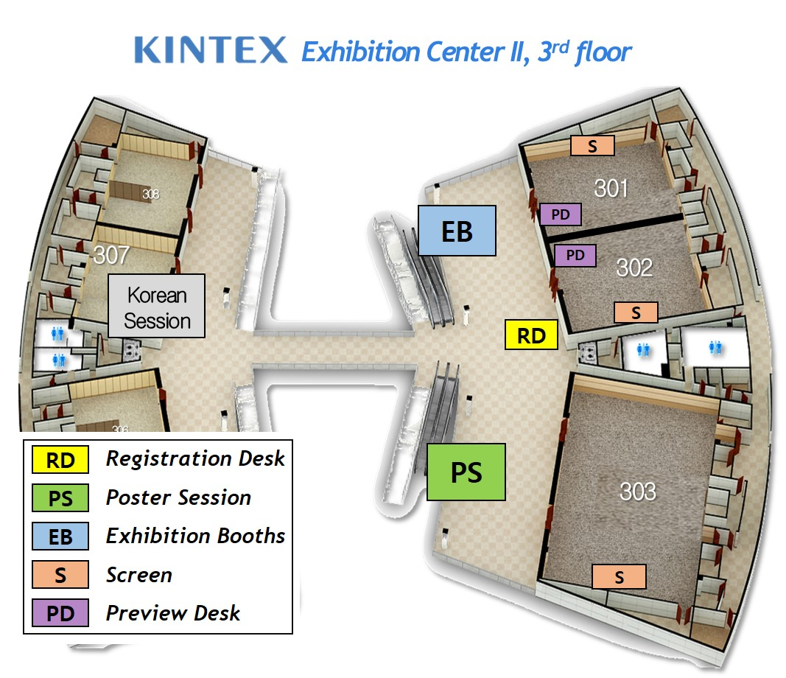
Room Schedule
Room number | Introduction | Tuesday 12th  November | Wednesday 13th  November | Thursday 14th  November
301 | 100 Seats  Classroom Type |  | Technical Sessions 1, 3 | Technical Session 5  Korean Session 5
302 | 100 Seats  Classroom Type | Workshops 1~4 | Technical Sessions 2, 4 | Technical Sessions 6, 7  Announcement for TIEMS 2020  Summary & Conclusions
303 | 200 Seats  Round Table | Welcome reception | Welcome & Opening  Plenary Session 1  Annual General Meeting  Gala Dinner | Plenary Session 2
307A | 25-30 Seats  Seminar Room Type |  | Korean Sessions 1, 2 | Korean Sessions 3, 4
Daily Program Details
PROGRAM DAY 1 - TUESDAY NOVEMBER 12, 2019
WORKSHOPS (Room No. 302)

REGISTRATION FROM 08:00
09:00-09:10 | Welcome & Introduction of the Workshops  K. Harald Drager  TIEMS President
09:10-11:00 | Workshop 1  Comprehensive Disaster Reduction, Preparedness, Emergency Response and Recovery  Workshop Chair: Prof. Guosheng Qu, and Prof. LI Jing,China and Ibrahim CAGLAR, TRNC  Objectives  Capacity Assessment of Emergency Preparedness of Comprehensive Disaster, Improvements of Regional Resilience, Emergency Response and Rescue: Capacity Buildings of Comprehensive Rescue for Various Disasters (Water/Flooding, Mountains, USARs, Aviation, Wildfire etc), Disaster Recovery.  Workshop Program  - Capacity Buildings of IN-USAR/N-USAR/CERT–FR and IEC/IRNAP/ CERT Certification  Speaker: QU Guosheng, MEM, China  - Emergency Response, USAR Capacity Buildings and Future Plan of TRNC.  Speaker: Ibrahim CAGLAR, NEMA, Turkish Republic of Northern Cyprus (TRNC)  - Emergency Response, USAR Capacity Buildings and Future Plan of Mongolia  Speaker: L. Ulziibayar, NEMA, Mongolia  - Emergency Management System and Natural Disaster Response in China  Speaker: LI Jing, Professor, Faculty of Geography, Beijing University, China  Zuoming Disaster Information Quick Collection, Real-time Disaster Assessment, SAR Support Platform and Case analysis.  Speaker: HAO Nan, Zuoming Disaster Information Center, China  - New plan of CERT/FRs Capacity Buildings in Developing Countries and Regions  Speaker: YANG Wenlong and FENG Yu, China  - The Disaster Emergency Response and SAR Scenario Technology Based on Disaster Risk Assessments.  Speaker: BU Bing, China
11:00-11:20 | Coffee Break with visit to Posters & Exhibition
11:20-13:00 | Workshop 2  ICT Practices on Disaster management  Workshop Chair: Dr. Yong Jai Lee, South Korea  Objectives  Case Studies related to IoT/smart factory, Cloud service, Big Data analysis, AR/VR will be introduced. It is expected that 4-5 Korean companies will present. Q&A and Discussions  Topic  1. Real-Time Location based Industry Safety management  Speaker: Jisung Kim, Geoplan Korea Co., Korea  2. Risk Based Smart Factory  Speaker: Seungshik Kang, RTworks Co., Korea  3. AWS Ground Station Intro  Speaker: Seokjae Jang, AWS Korea Public Section  4. Establishment of Safety Experience Education System Based on Virtual Reality [VR]  - Speaker: Billy Seo, CT I&C Co., Ltd. Korea
13:00-14:00 | Lunch with visit to Posters & Exhibition
14:00-15:40 | Workshop 3  NGO Roles in Emergency Management and Platform for Coordination, and Techniques Courses System and Scenario Simulation Infrastructures for Education, Training and Exercise  Workshop Chair: Dr. Zhang Qiang and Mr. Yang Wenlong, China  Objectives  NGO Roles in Emergency Management and Platform for Coordination, Cases of NGO Roles in Disaster Management. Advanced Concepts and Developments of Emergency Management and Techniques, Emergency Management and Techniques Courses System, Scenario Simulation Infrastructures for Education, Training and Exercise, Education, Training and Exercise Courses for Emergency Management and Emergency Industry.  Workshop Program  - NGO’s Roles in Emergency Response and Rescue in China.  Speaker: Bravan ZHANG Qiang and XU Shiling, Beijing Normal University, China  - Emergency Management Foundation and the future support for NGOs and TIEMS in Activities of Emergency Management Issues.  Speaker: QIU Lili, Peace Foundation, China  - Case Analysis of NGO Roles in Emergency Management and Platform. Speaker: XIE Aize, NGO Organization of Shaanxi Province, China  - Emergency Management Industry Park and Their New Development in China.  Speaker: YANG Wenlong, China  - A rustic opinion of construction of emergency rescue capability system assisted by commonweal foundation  - Speaker: ZHOU Hao, Fire Prevention and Safety Public Welfare Foundation, China
15:40-16:00 | Coffee Break with visit to Posters & Exhibition
16:00-18:00 | Workshop 4  TIEMS International Certification – TQC  Workshop Chair: Dr. Sandro Bologna, Italy  Objectives  An update of the TQC concept, TQC functional requirements and implementation of TQC software platform - experience and further plans. Q&A and Discussions.  Workshop Program  - Introduction to the Workshop and Needs for Certification  Speaker: K. Harald Drager, Norway  - TQC General Policy and Progress  Speaker: Sandro Bologna, Italy  - TQC Compliance and CV Minimum Requirements  Speaker: Thomas Robertson, USA & Snježana Knezic, Croatia  - TQC Examination Requirements and Procedures  Speaker: Sandro Bologna, Italy  - TQC Platform Requirements and State of Art Implementation  Speaker: Sandro Bologna, Italy & K. Harald Drager, Norway  - End User Expectations and Preliminary Considerations  Speaker: Roman Tandlich, South Africa  - Q&A and Discussions  Closing
18:00-20:00 | Welcome Reception  (Room No. 303)
20:00 | Finish Day 1

PROGRAM DAY 2 - WEDNESDAY NOVEMBER 13, 2019
PRESENTATION (Room No. 301, 302, 303, 307)

REGISTRATION FROM 08:00
Plenary Session 1
(Room No. 303)
Chair: Roman Tandlich(South Africa), Baeg Lee (Korea)
09:00-09:30 | Emergency Management around the World - Challenges and Lessons Learned  K. Harald Drager  TIEMS President, Norway
09:30-10:00 | Adaptation technology of infrastructure under climate change  Dr. Sangseom Jeong  South Korea
10:00-10:30 | Public Safety: The State of Civil Protection Around the World  Mr. Mare Lo and Dr. Josef Leitmann  USA
10:30-10:45 | Opening Ceremony  (Room No. 303)  Chair: Baeg Lee (Korea)  Welcome Address  Ji-Hyeob Ryu, President, KSDS & Hanlyo Univ.  Congratulatory Remarks  Gye-Jo Kim, Vice Minister, Ministry of the Interior & Safety  Sarah Wade-Apicella, UN Office of Disaster Risk Reduction
10:45-11:00 | Coffee Break with visit to Posters & Exhibition
11:00-11:30 | Safety Issues in Construction Market Facing Industry 4.0.  Dr. Seok Hong Lee  South Korea
11:30-12:00 | The New National Emergency Management Systems in China, its Focus, Experience so far, and Future Plans  Dr. Guosheng Qu  China
12:00-13:00 | TIEMS Annual General Meeting  (Room No. 303)
13:00-14:00 | Lunch with visit to Posters & Exhibition
14:00-15:40 | Technical Session 1  (Room No. 301)  Chair: Thomas Robertson(USA), Byoungjae Lee(Korea)
14:00-15:40 | Zhang Shifu, Xie Changhua, Mao Yuwen, Deng Xianyi, Zhang Dongmei and Li Cunjing China | Development and application for mobile emergency drainage system in urban flood rescue
14:00-15:40 | Soon-Joo Wang  Korea | New technologies in Emergency Situation: Focusing on Healthcare including Artificial Intelligence
14:00-15:40 | Yeon Woo Choi and Dong Keun Yoon  Korea | Accessibility vulnerability analysis of fire-fighting response service using network analysis in Seoul, Korea
14:00-15:40 | Yusuf Eker,  North Cyprus | Disaster Emergency Services and Humanitarian Activities with the Goal of Disaster Resilient Society in Northern Cyprus, National Achievements, International Challenges and Obstacles
14:00-15:40 | Technical Session 2  (Room No. 302)  Chair: Alex Fullick(Canada)
14:00-15:40 | Ji Hye Ha and Jung Eun Kang Korea | A study on Flood Prediction Using Machine Learning: Focused on Busan Metropolitan City
14:00-15:40 | Alex Fullick,  Canada | Reduce Fear - Increase Resiliency
14:00-15:40 | Gi Hwan Kwon, Jeong Rim Oh, Young Jin Son, Jun Hyung Park and Min Jung Kim  Korea | A Study on the Professional Development Plan for disaster and safety management in Korea
14:00-15:40 | Se Noori  Korea | Discussions on "The Right for Security" in Korea - Constitutional Amendment Proposal by the Government and Interpretation of the Current Constitution
15:40-16:00 | Coffee Break with visit to Posters & Exhibition
16:00-18:00 | Technical Session 3  (Room No. 301)  Chair: Snježana Knezić(Croatia), Seunghee Park(Korea)
16:00-18:00 | Chang Woo Lee, Sang-Hyeok Nam and Seonggon Kim  Korea | Practical use of geospatial data for extreme-temperature disaster response
16:00-18:00 | Snježana Knezić and Martina Baučić  Croatia | Social media based emergency decision support system
16:00-18:00 | Namgyun Kim, Jaehwan Kwak and Man-Il Kim  Korea | Development of decision tree for response forest fire through the comparative case analysis of large wildfire
16:00-18:00 | Dai Quoc Tran, Minsoo Park, Vu Tuan Tran, Dae-Kyo Jung and Seunghee Park  Korea | A Survey on Machine Learning Approaches for Natural Disaster Management System
16:00-18:00 | Vu Tuan Tran, Jihyun Lee, Junghyun Im, Dae-Kyo Jung and Seunghee Park  Korea | A conceptual framework for an intelligence natural disaster management system
16:00-18:00 | Technical Session 4  (Room No. 302)  Chair: Jean-Paul Monet(France), B.Han Choi(Korea)
16:00-18:00 | Mannaioni A., Schaller P., Saint Jonsson A., Monet J.P.  France | International crisis management, how to evaluate the quality of interoperability? Definition of a methodology, study cases at national and international level.
16:00-18:00 | Seongyun Park, Gwangsun Shin and Sanghun Lee  Korea |  | Implication of Earthquake Disaster Prevention System in Japan to Mitigate Earthquake Damage in Korea
16:00-18:00 | Jaiho Oh, Mo-Ryang Hur, Ji-Won Oh, Hong-Hee Kim and Ji-Han Shim  Korea |  | Living Lab. in EDC: A Scientific Research Mesh Network for Future Disaster Management for Extreme Weather in the City
16:00-18:00 | James Giles and Charles Du Plessis  Singapore and Australia | Training and Technology for a Safer and More Effective Forest Fire Fighting
16:00-18:00 | M. Bhaskara Rao  India | Mainstreaming Disaster Risk Reduction into Development in the SAARC Region: Need for Integration of DRR into Development Activities and Strengthen Knowledge Management
16:00-18:00 | Woo Sik Kim and Dong Keun Yoon  Korea | Examining Factors Contributing to Crime Occurrence in Urban Areas, Korea
18:00-20:00 | Gala Dinner  (Room No. 303)
20:00 | Finish Day 2

PROGRAM DAY 3 - THURSDAY NOVEMBER 14, 2019
PRESENTATION (Room No. 301, 302, 303, 307)

REGISTRATION FROM 0800
Plenary Session 2
(Room No. 303)
Chair: Jaroslav Pejcoch(Czech Republic), Kyooman Ha (Korea)
08:30-09:00 | Search and Rescue (SAR) in the Arctic, Status and Challenges  Bent - Ove Jamtli  Norway
09:00-09:30 | Current status and tasks of marine disasters management in Korea  Dr. Ja-Yeong Gu  South Korea
09:30-10:00 | Emergency Benefits and Risks of Artificial Intelligence  Dr. Thomas Robertson  USA
10:00-10:30 | Engineering Design Considerations for Small Debris-Flow Mitigation Structures  Dr. Sangjun Im  South Korea
10:30-11:00 | EU’s RTD Programs, and the Participation of Non-EU countries in RTD Proposals  Dalibor P. Drljaca  Bosnia and Herzegovina
11:00-11:20 | Coffee Break with visit to Posters & Exhibition
11:20-13:00 | Technical Session 5  (Room No. 301)  Chair: Guosheng Qu(China), Kumsook We(Korea)
11:20-13:00 | Ji Yoon Lee and Jung Eun Kang  Korea | Estimating Damage by Rising Sea Levels with Focus on Busan Metropolitan City
11:20-13:00 | Moonhyun Hong and Sangseom Jeong  Korea | Geodisaster-induced landslides and debris flows in Region scale area
11:20-13:00 | Bijia Zhang, Shufeng Xi, Yuyang Liu and Yuanyuan Jiao  China | Natural Disaster Prevention and Mitigation System Based on Disaster Investigation and Assessment
11:20-13:00 | Mao Yuwen, Hu Yongpan and Qin Tingxin  China | Development of disaster analysis and rescue treatment standard in plateau and ultra-cold area of China
11:20-13:00 | Inese Barbare  Latvia | The impact of the project ONBOARDMED on development of study courses in maritime emergency management
11:20-13:00 | Technical Session 6  (Room No. 302)  Chair: Roman Tandlich(South Africa), Changsam Jeong(Korea)
11:20-13:00 | Zhang Shifu, Mao Yuwen, Xie Changhua and Hu Yongpan  China | First Response Mechanism and Support Technology in Highway Traffic Emergency Resume Process
11:20-13:00 | Kyung Tae Lee  Korea | Through analysis of domestic earthquake data Relationship between scale and epicenter damage
11:20-13:00 | E. P. Vhiriri, R.K. Laubscher, Y. Irwin, R. Tandlich  South Africa | Water, sanitation and disaster management in isolated settlements in the Pacific Islands
11:20-13:00 | Phil Kyu Jung, Ji Yun Kim and Yung Il Yun  Korea | A Study on the Current Status and Method of Seismic Retrofit of Public Facilities in Gyeonggi-do
11:20-13:00 | Mijin Choo and Dong Keun Yoon  Korea | Examining the effects of community’s social capital on disaster risk in Seoul, Korea
13:00-14:00 | Lunch with visit to Posters & Exhibition
14:00-16:00 | Technical Session 7  (Room No. 302)  Chair: Jaroslav Pejcoch(Czech Republic), Baeg Lee(Korea)
14:00-16:00 | Jaroslav Pejcoch  Czech Republic | Pre-accident awareness made real
14:00-16:00 | Dong Eun Lee, Ki Hoon Cho, Ho Jin Jang and Dong Heon Kim  Korea | A Study on the Evaluation of the Vulnerabilities in Climate Change
14:00-16:00 | Hyungjun Park, Daejin Lee, Huiwon Yang and Junbeom Lee  Korea | Liquefaction Analysis of Earthquakes in Korea
14:00-16:00 | Sandro Bologna,  Italy | A set of Good Practices and Recommendations for Smart City Resilience Engineering and Evaluation
14:00-16:00 | J. Wong, N. Lai and T. Zhou  China | Evaluating Crisis Intervention Practices with an EM Hexagon Model - the case of four Chinese cities
16:00-16:20 | Coffee Break with visit to Posters & Exhibition
16:20-16:40 | TIEMS 2020 Annual Conference Concept in France  (Room No. 302)  Jean–Paul Monet (TIEMS Regional Director for Europe)
16:40-17:00 | Summary & Conclusions  (Room No. 302)
17:00 | Finish Day 3

PROGRAM DAY 4 - FRIDAY NOVEMBER 15, 2019
GUIDED TOUR
07:00-13:00 | Guided Tour  Visit to  1) Songpa Safety Experience Education Center  Public institution for safety education using experience, practice, multimedia, VR.  2) Lotte Tower (Safety Control Center)  Lotte Tower is the newly constructed modern building which is the highest in Korea and the 5th highest in the world (555m, 123 floor). There are safety control center and escape floors in Lotte Tower.
13:00–14:00 | Late Lunch
14:00 | Farewell
End of Conference

Poster Sessions (3rd Floor Corridor)
Myoungsun Han  Korea | Installation of River Information display system
Jaewon Shim, Jiyoung Rhee, Taesun Chang and Nagyoung Kim  Korea | Simulation and Test on Explosion Resistance of Tunnel Lining Concrete using 3D-AUTODYN and Shock Tube
Siviwe Shwababa  South Africa | Assessing the impact of wild fires in land reform farms, a case of land reform beneficiaries in South Africa
Lim Sehun, Jeong Kyungok and Lee Dongeun  Korea | Applying the perspective of regional competitiveness of urban resilience A Study on Improvement of life safety Index
Hyesook Jeon, Kwonmin Lee, Yeseul Lee, Eun-Gyu Park and Yong-Sang Choi  Korea | The Effective Disaster Response in Cambodia: Implications from Focus Group Interview
Jang-Gyeong Kim, Chang-Sam Jeong and Hyun-Han Kwon  Korea | A hierarchical Bayesian approach to the Neyman-Scott rectangular pulse model for a joint estimation of model parameters across stations
Jiyoung Rhee, Jaewon Shim, Taesun Chang and Nagyoung Kim  Korea | Fire Safety Plan at Occupation Areas under Bridge to Minimize Fire Damage on Bridge
Yun Joo Lee, Ha Rim Kim, Soyeon Yoon and Dong Keun Yoon  Korea | Examining the disaster response system for the disabled in Korea
Andre Samberg, Finland/Ukraine | An Overview of the Current International Regulation and Standards for Disinter Risk Reduction and Civil Protection

